Drinking Water Quality Management Plan (DWQMP) report
Cherbourg Aboriginal Shire Council
July 2017 – June 2018
SPID: 146

22 Barambah Avenue
Cherbourg Qld 4605

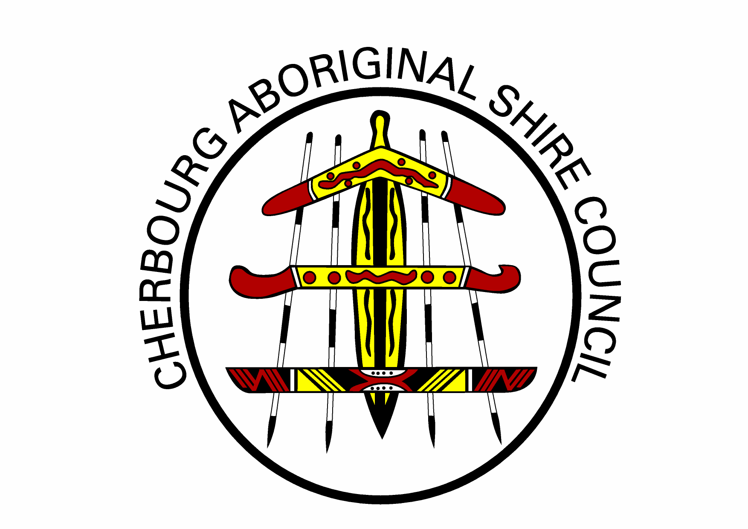

Glossary of terms

ADWG 2004 | Australian Drinking Water Guidelines (2004). Published by the National Health and Medical Research Council of Australia
ADWG 2011 | Australian Drinking Water Guidelines (2011). Published by the National Health and Medical Research Council of Australia
E. coli | Escherichia coli, a bacterium which is considered to indicate the presence of faecal contamination and therefore potential health risk
HACCP | Hazard Analysis and Critical Control Points certification for protecting drinking water quality
mg/L | Milligrams per litre
NTU | Nephelometric Turbidity Units
MPN/100mL | Most probable number per 100 millilitres
CFU/100mL | Colony forming units per 100 millilitres
< | Less than
> | Greater than

This report has been prepared in accordance with the Drinking Water Quality Management Plan Report Guidance Note.

Introduction
This report documents the performance of Cherbourg Aboriginal Shire Council’s (the council) drinking water service with respect to water quality and performance in implementing the actions detailed in the drinking water quality management plan (DWQMP) as required under the Water Supply (Safety and Reliability) Act 2008 (the Act).
The report assists the Regulator to determine whether the approved DWQMP and any approval conditions have been complied with and provides a mechanism for providers to report publicly on their performance in managing drinking water quality.

- Overview of Operations
Cherbourg water treatment plant sources raw water from The Rocks on Barambah Creek downstream of Bjelke Petersen Dam. The treatment comprises addition of liquid alum, clarification, filtration through a rapid sand filter, pH adjustment using soda ash and disinfection using sodium hypochlorite. Treated and disinfected water is delivered to the reticulation through a clear water tank and 2 clear water reservoirs.

- Actions taken to implement the DWQMP
- Progress in implementing the risk management improvement program
Refer to the Appendix B for a summary of progress in implementing each of the Improvement Program actions from the approved DWQMP.
- Revisions made to the operational monitoring program to assist in maintaining the compliance with water quality criteria in verification monitoring.
Council made no changes to the Operational & Verification monitoring programs in the Revised February 2018 (Version 2) approved DWQMP.
- Amendments made to the DWQMP

Amendments were made to the DWQMP, the amended plan was submitted to the regulator on 19th February 2018. A information notice for the decision was issued on the 9th April 2018. The plan was approved with conditions.
- Compliance with water quality criteria for drinking water
Council has implemented a verification-monitoring program as per the approved DWQMP. At present Cherbourg Aboriginal Shire council monitors for microbiological parameter e.g. E.coli in its reticulation.
Not all samples taken in 2017/18 financial year were compliant. Found 2x E.coli detection and non compliance, reported incidents to regulators. All samples are externally tested by QHFSS laboratory in Brisbane.
Council is also undertaking monitoring of other parameters e.g. chlorine residual, pH and turbidity and raw water in its reticulation. Samples are taken to Wondai for testing every week. Samples of THM’s are also taken weekly along with micro-samples.

- Compliance with water quality criteria for drinking water
Council has implemented a verification-monitoring program as per the approved DWQMP. At present Cherbourg Aboriginal Shire council monitors for microbiological parameter e.g. E.coli in its reticulation.
Not all samples taken in 2017/18 financial year were compliant. All samples are externally tested by QHFSS laboratory in Brisbane.
Council is also undertaking monitoring of other parameters e.g. chlorine residual, pH and turbidity and raw water in its reticulation. Samples are taken to Wondai for testing every week. Samples of THM’s are also taken weekly along with micro-samples.

- Notifications to the Regulator under sections 102 and 102A of the Act
- Non-compliance with the water quality criteria and corrective and preventive actions undertaken
This financial year there were 2x incidents where the Regulator was notified under section 102 of the Act.
- Prescribed incidents or Events reported to the Regulator and corrective and preventive actions undertaken.
In the 2017-18 financial year, there were 2x incidents or events that were reported to the Regulator.

2. Summary of scheme/s operated

Cherbourg water treatment plant sources raw water from The Rocks on Barambah Creek downstream of Bjelke Petersen Dam. The treatment comprises addition of liquid alum, clarification, filtration through a rapid sand filter, pH adjustment using soda ash and disinfection using sodium hypochlorite. Treated and disinfected water is delivered to the reticulation through a clear water tank and 2 clear water reservoirs.

Table 1 – Summary of schemes
 | Water Source | Treatment processes | Treatment capacity | Towns supplied
 | Barambah creek | Liquid Alum, Clarification | 2x reservoirs | Cherbourg
 | Downstream BP dam | Filtration - (sand filter)
 |  | Soda ash - PH
 |  | Disinfection – Sodium hypochlorite

The actions undertaken to implement the risk management improvement program are discussed in Table 2. .
Table 2 – Risk management improvement program implementation status
Scheme name | Ref | Component | Improvement actions | Target date | Actions taken to date | Status and revised target date | Responsible Officer / Position
Cherbourg |  | Record keeping | Chemical data complaints | June 2013 | Completed and ongoing | June 2013 | EHW/WTP operator
Cherbourg |  | Reticulation | Replacement of valves | December 2019 | Not Completed | December 2019
Cherbourg |  | Procedures | Develop O&M procedures | July 2018 | Not Completed | June 2020

Verification monitoring - water quality information and summary
This section discusses the compliance with the water quality criteria.
Council has implemented a verification-monitoring program as per the approved DWQMP. At present Cherbourg Aboriginal Shire council monitors for microbiological parameter e.g. E.coli in its reticulation.
Samples taken in 2017/18 financial year two e.coli incidents were detected.
Council is also undertaking monitoring of other parameters e.g. chlorine residual, pH and turbidity and raw water in its reticulation. Samples are taken to Wondai for testing every week. Samples of THM’s are also taken weekly along with micro-samples.

Table 3 – Drinking water quality performance - verification monitoring
Scheme name | Parameter | No. of samples required to be collected (as per the approved DWQMP) | No. of samples actually collected and tested | Water quality criteria (i.e ADWG health guideline value) | No. of non compliant samples | Comments
Cherbourg | E.coli | 52, weekly | 157 | 0 | 2
Cherbourg | Free chlorine | Weekly | 196 | 0.20 – 0.50
Cherbourg | Total chlorine | Weekly | 196 | 0.2 – 2.0
Cherbourg | PH | Weekly | 196 | 7.5 – 8.5

Use the E.coli compliance with annual value figures for the reporting period from the excel spreadsheet tool to populate Table 4. Use one table per scheme
Table 4. E. coli compliance with annual value
Drinking water scheme: | Cherbourg
Year | 2017 – 2018
Month | July | Aug | Sept | Oct | Nov | Dec | Jan | Feb | Mar | Apr | May | Jun
No. of samples collected | 4 | 4 | 16 | 8 | 13 | 8 | 9 | 25 | 10 | 15 | 25 | 20
No. of samples collected in which E. coli is detected (i.e. a failure) | 0 | 0 | 0 | 0 | 0 | 0 | 0 | 0 | 0 | 1 | 0 | 0
No. of samples collected in previous 12 month period | 4 | 4 | 16 | 8 | 13 | 8 | 16 | 21 | 16 | 12 | 20 | 16
No. of failures for previous 12 month period | 0 | 0 | 0 | 0 | 0 | 0 | 0 | 0 | 0 | 0 | 0 | 0
% of samples that comply | 100.0% | 100.0% | 100.0% | 100.0% | 100.0% | 100.0% | 100.0% | 100.0% | 100.0% | 99.0% | 100.0% | 100.0%
Compliance with 98% annual value | Yes | Yes | Yes | Yes | Yes | Yes | Yes | Yes | Yes | Yes | Yes | Yes

Incidents reported to the regulator
The incidents reported to the regulator and management actions undertaken over the financial year are provided in this section.
Refer to section 2.3.5 in the Guidance Note. Table 5 can be used to present a summary of the incidents you have reported to the regulator. Use the examples in Table 5 in the Guidance Note to populate this table.

Table 5 – Incidents reported to the regulator
Incident date | Scheme / location | Parameter / issue | Preventive actions
4.4.2018 | Cherbourg, Bert button lookout | E.coli (1) | Boil water alert notices
28.4.2018 | Cherbourg, Bert button lookout | E.coli (1) | Dumped/Flushed storage tanks
 |  |  | Manually dose storage tanks
 |  |  | Repair/Replace storage tanks lids, bolt+lock lids into tanks

Customer complaints
This section discusses details of any complaints received about the drinking water service
Refer to section 2.3.6 in the Guidance Note.
Table 6 can be used to present the details of any customer feedback you have received during the reporting period. Use the examples in Table 6 in the Guidance Note to populate this table.
Table 6 – Example: customer complaints about water quality
Scheme | Health concern | Dirty water | Taste and odour | Other
Cherbourg
Total 0

Refer to Box 3 in section 2.3.6 of the Guidance Note for an example of how to describe your responses to customer complaints
Click or tap here to enter text.

DWQMP review outcomes
A summary of the outcomes of the review and how issues/changes raised in the review, were actioned is provided in this section.
Refer to section 2.3.7 in the Guidance Note. Table 7 can be used to present the summary of the review outcomes. Use the examples in Table 7 in the Guidance Note to populate this table.
Table 7 – DWQMP review outcomes
Review Date: DD/MM/YY
Review component | Findings | Outcomes | Status of actions | Responsible Officer / Position
Service description
Details of infrastructure | Schematic incorrect | Corrected schematic | Completed | Operations manager
Water quality and catchment characteristics
Risk assessment
Operations and maintenance procedures | No process control plan for PAC | Created process plan for PAC | Completed | Operations manager
Management of incidents and emergencies
Risk management improvement program |  | Updated | Completed
Service wide information management
Operational monitoring
Verification monitoring |  | THM updated | Completed | Operations manager

The actions undertaken to address the audit recommendations are outlined in Table 8.
Use the examples in Table 8 in the Guidance Note to populate the table below.
Table 8 – DWQMP audit findings and status
Item | Recommendation or OFI | Action | Status of actions | Responsible Officer / Position

