Darling Downs Health, Child and Youth Mental Health Service (CYMHS) invites you to attend
Youth Mental Health First Aid
The 14-hour Youth Mental Health First Aid (MHFA) Course teaches adults (18 years and over) how to provide initial support to adolescents who are developing a mental illness or experiencing a mental health crisis.
Date & Time: Thursday 15th July 9am to 4pm
Thursday 22nd July 9am to 4pm
Participants to attend both days to receive Mental Health First Aid certificate.

Venue: Cherbourg Community Council Training Room
Fisher Street, Cherbourg

Facilitators: Anita Smith (Rural Ed LinQ Coordinator - Senior Psychologist)

Cost: FREE. Morning Tea & Lunch will be provided.
All participants will receive a YMHFA manual and certificate.

Course Content
Mental illnesses often start in adolescent or early adulthood, and it is important to detect problems early to ensure the young person is properly treated and supported. The YMHFA course teaches adults who have frequent contact with adolescents such as parents, guardians, school staff, sport coaches and youth workers, how to assist adolescents who are developing a mental health problem or are in a mental health crisis. The YMHFA course teaches adults how to assist adolescents who are developing any of the following mental health problems or mental health crises:

Developing mental health problems: Mental Health Crises:
* Depression * Suicidal thoughts and behaviours
* Anxiety * Non-suicidal self-injury
* Eating disorders * Panic attacks
* Psychosis * Traumatic events
* Substance use problems * Severe Psychotic states
* Severe effects from alcohol/other drug use
* Aggressive behaviours
* Medical emergencies with eating disorders

Participants will learn about adolescent development and the signs and symptoms of mental health problems, how and where to get help and what sort of help has been show by research to be effective.

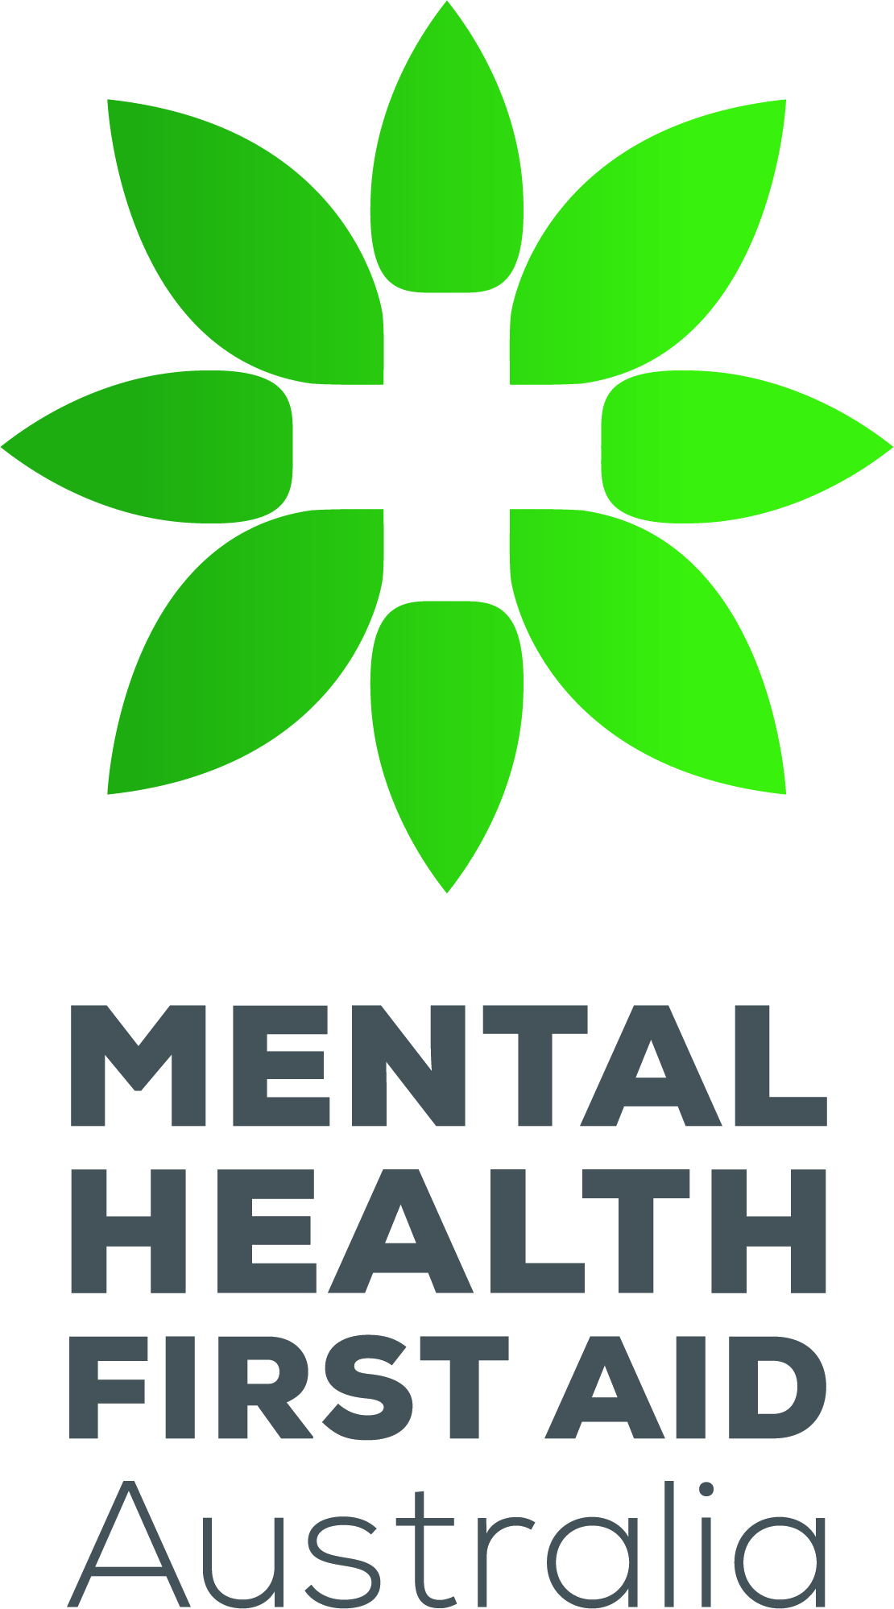
Please email your registration for this course to Anita Smith at anita.smith2@health.qld.gov.au or 0436 818 210.

